Burpham Church Fabric Report 2016

2016 saw a number of problems arise with our buildings, arising principally from their age, but the creation of one important new facility which should greatly enhance the ministry of the church.

St Luke’s Church

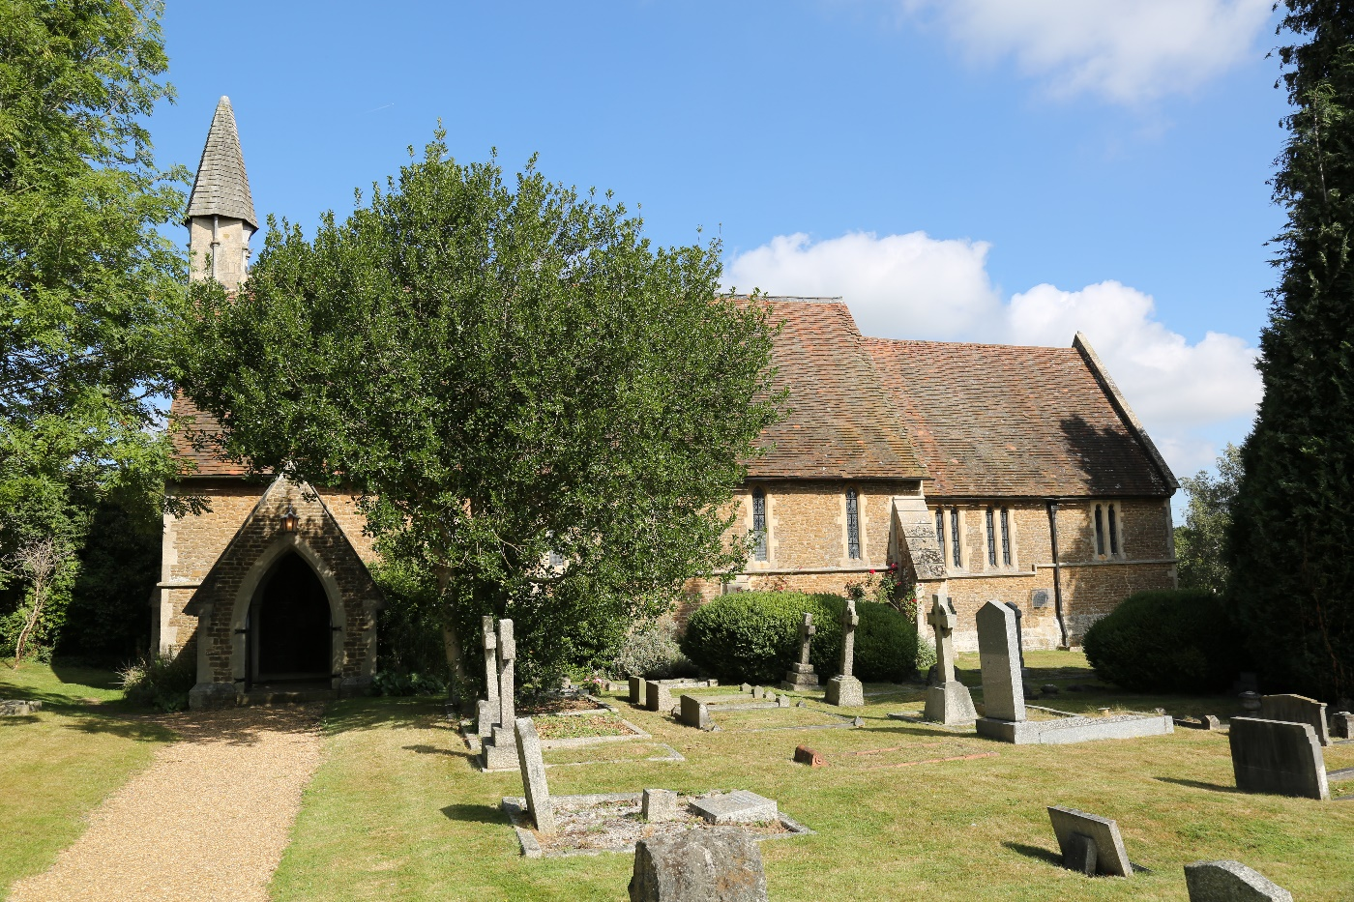

We have mentioned previously that St Luke’s has survived with remarkably little expenditure on maintenance for a long time but the 2012 quinquennial inspection identified that significant investment would be necessary.
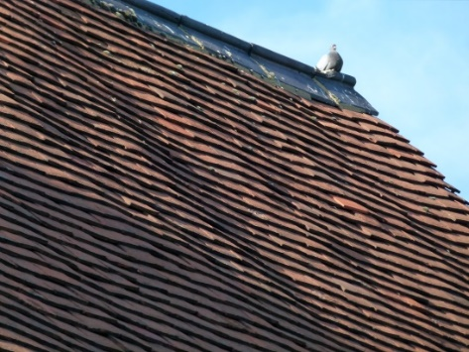

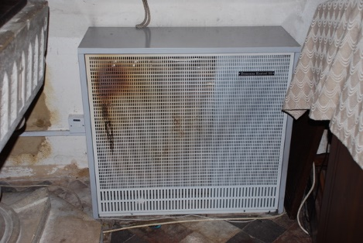
- The biggest item was the need to re-roof the whole church replacing the roof tiles and supporting battens. We applied for a Government Roof Grant for a second time but again were unsuccessful.

- Next in scale was replacement of the electrical wiring which we had said we would replace in 2016, following an inspection in 2014. We were beginning to get prices for rewiring when a routine maintenance inspection of the gas heaters in the church identified that they were in very poor condition, and in fact unsafe to use, and were immediately disconnected. The picture shows the state of one of them.
- The PCC considered carefully what to do and discussed the situation further with the diocese, the quinquennial inspecting architect and members of the church family who regularly attend services at St Luke’s. It was felt quite possible that the roof would last several years more, although there can be no certainty of this, but without the rewiring and replacement heating St Luke’s would have to close by winter 2016. Consideration was also given as to whether to replace the gas heating with electric heating the initial cost of which would be much lower.
- Following generous giving by church members and with the aid of a legacy from someone who previously regularly attended St Luke’s, the cost of rewiring and replacement gas heating was found.
- It was possible to use a new simplified faculty procedure for this work and so with help from the diocese to put that through quickly we were able to carry out the work and complete it at the beginning of December, just in time for two Weddings and a Carol Service!

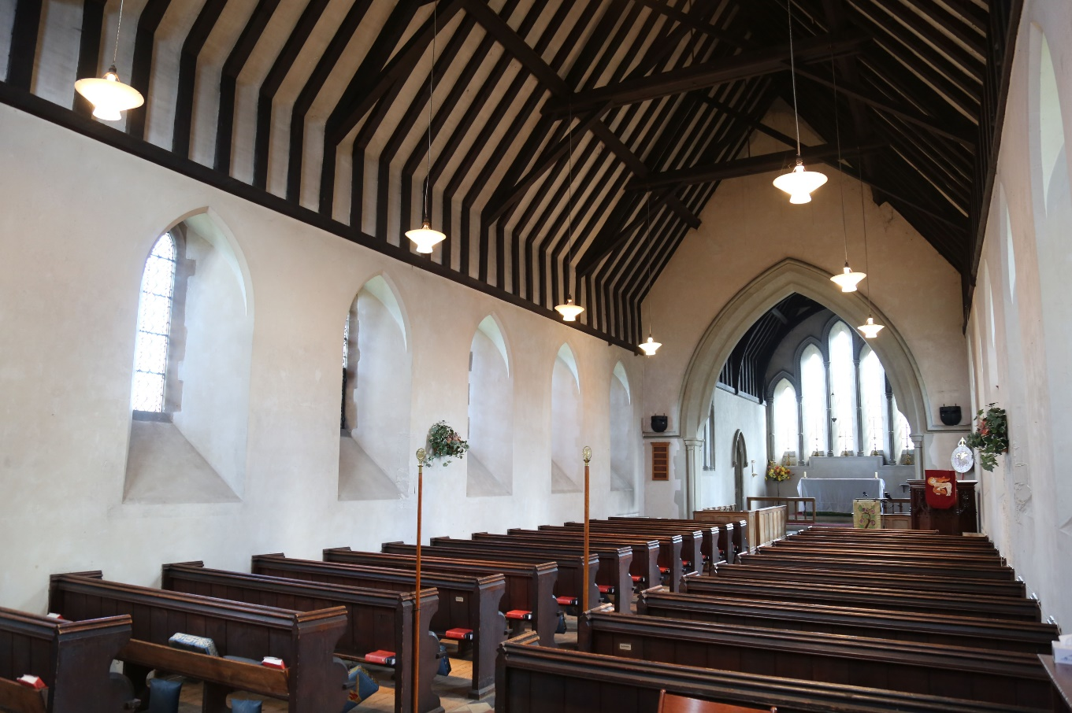

Church of the Holy Spirit

The Church of the Holy Spirit celebrated it’s 50th Birthday last year, and while many parts of CHS have benefited from major refurbishment works in recent years, unfortunately the parts which have not received much attention are showing their age.
- We warned last year (as previously) that the flat roofed section at the front of the site is in poor condition and near the end of its life. Its roof has proved the accuracy of this with a vengeance this year. There have been a series of leaks, and a series of attempts to repair them, including a lot of work by one of our vicars, as well as more expensive professional help. Flat roofs are notoriously difficult at the best of times but when this age it is particularly difficult to trace the source of leaks and repair them. At the time of writing this report we believe we have cured the leaks, and the roof has withstood some severe weather, but we cannot rule out further problems.  - Another problem this year was a serious pothole appearing in the tarmac surface near the front of our site. It is believed this is settlement from drainage work that was done here 12-15 years ago. Having got quotes for doing a professional repair we felt unable to afford that and have carried out a repair ourselves. Further work may be necessary in a year or two’s time but the saving to us has been significant. | 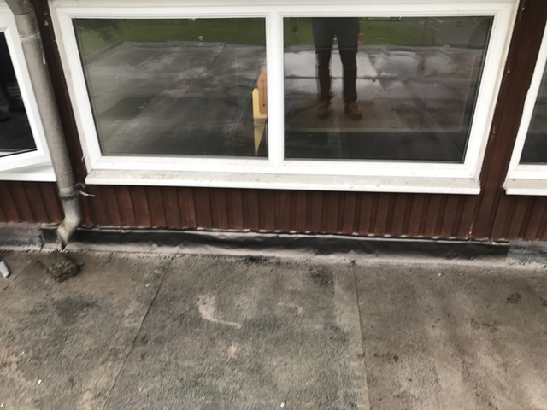  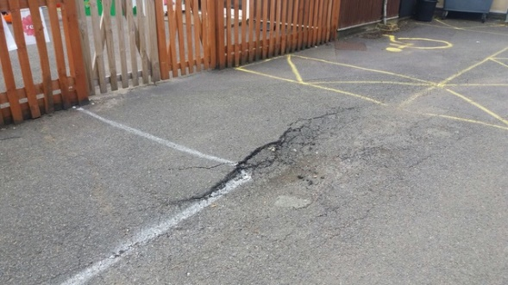
The positive aspect of the buildings at CHS is creation of the Barnabas Room out of the space left above the kitchen and store in the hall, introducing a staircase up from the foyer with a stairlift to access it. Work on this started in the summer and was completed in September. We are delighted with the end result and a room that is already making a significant difference to our ministry.
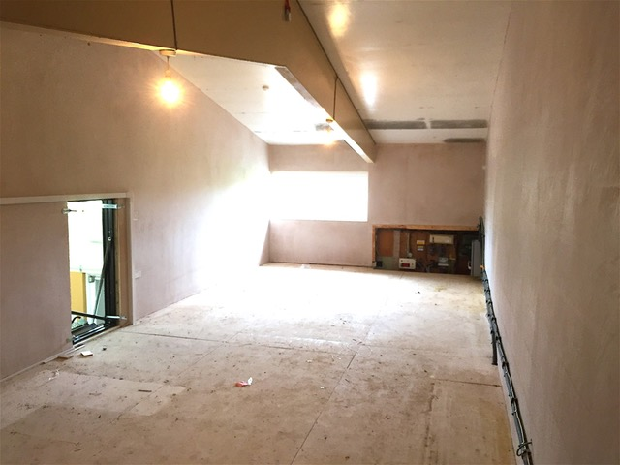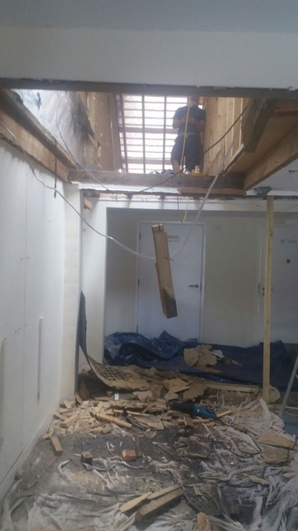
The original empty space after clearing it. Cutting through for the stairs
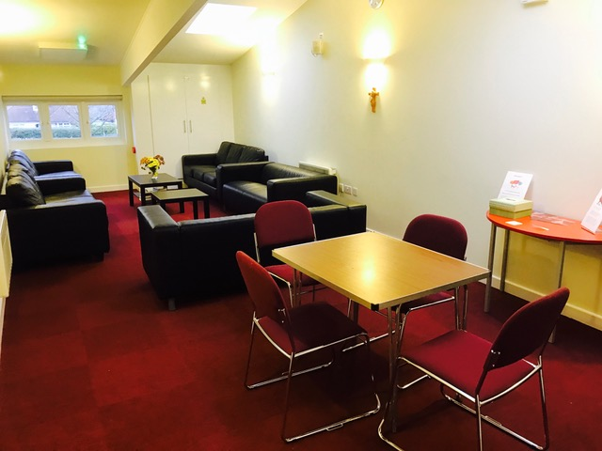
The completed Barnabas Room

Planning for the future

The PCC has begun the task of considering where our next investment should be. There are pressing needs at both St Luke’s and CHS to replace time expired fabric, but also opportunities at both to enhance our ministry. Much thought and prayer will be going into this as substantial further funding will be necessary.

Thank you

Once again we would like to thank the church family for their generosity both in time and financially. Substantial funds were raised both for the Barnabas Room and for the heating and electrics at St Luke’s. Much work has been done by volunteers both at working parties and on other occasions particularly at CHS in the last year.

